Exam : Computational Statistics Hassaan Tahir

Assignment 1: Likelihood optimization

- Load necessary information concerning Otago city to R. Plot the histogram of the wind speed and comment whether it looks like Weibull (you may also compare it with the shape of the related Rayleigh distribution)

ot<-read.csv(file="z:\\ot.csv",head=TRUE,sep=";")
hist(ot[,1])

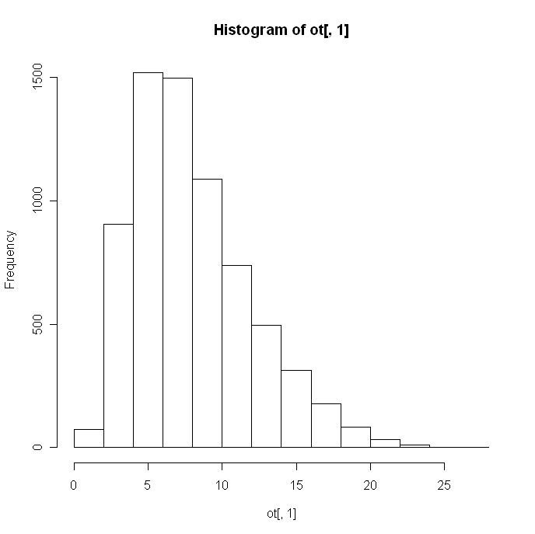*0.5p

It’s a weibull distribution because the distribution is skewed towards the right. Weibull is a generalized exponential distribution; i.e., the exponential is a special case of the Weibull where the alpha parameter equals 1.0. *0.5p

- Write your own function as a parameter of the data that finds the maximum log-likelihood estimates of the parameters shape and scale of the Weibull distribution by using an optimization method such as BFGS or CG. Compute the parameter estimates (if you get warnings, ignore them). What kind of problems may one encounter when these methods are used for the search of the maximum log-likelihood estimates? What other methods can you see as alternatives that do not have these problems?

Code:
fun<-function(theta,y){
sc<-theta[1]
sh<-theta[2]
n<-length(y)
l<-(n*log(sh))+(n*sh)*log(sc)+(sh-1)*sum(log(y))-(sc^sh)*(sum(y)^sh)
return(l)
}
optim(c(1,1),fun,y=ot,method="BFGS")
*0.5p You are minimizing likelihood instead of maximizing…

Method= BFGS
Initial value | Scale | Shape | Convergence | Function Value | Function Count
1,1 | 38.950499 | 4.553216 | Yes | -2.757403e+210 | 333
2,10 | 10.06218 | 31.57904 | Yes | -3.084723e+181 | 567
10,20 | 13.62192 | 43.95439 | Yes | -2.478344e+258 | 558
 | WRONG

With the method of BFGS, we found convergence but the value of function is too big.

Method= CG
With the method, CG, it gives me error like this
“non-finite value supplied by optim”

- Modify your function in such way that it returns only shape parameter. Consider this function as an estimator of shape and generate 100 bootstrap estimates of this parameter. Produce an appropriate plot and make comments. Compute 95% confidence bounds (using percentile method only!) for the parameter shape and answer whether the data can in principle come from Rayleigh distribution.

fun<-function(theta,y){
lam<-theta[1]
n<-length(y)
l<-log(lam)-lam*sum(y)
return(l)
}
result<-boot(data=ot[,1],fun,R=100) *0p WRONG

Bootstrap Statistics :
original bias std. error
t1* -181160980 61348.24 1262342
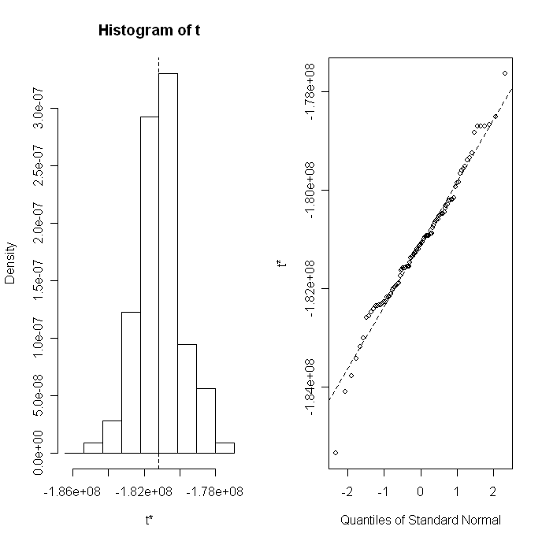

CALL :
boot.ci(boot.out = result, type = "perc", level = 0.95)

Intervals :
Level Percentile
95% (-183328205, -179111662 )

As we have the data of the wind speed, so it should have a Rayleigh distribution if the components of the two-dimensional wind velocity vector are uncorrelated and normally distributed with equal variance
Assignment 2: Computing an integral
Consider the distribution with density
- Write your own function that can generate sample of size n from the distribution above using the acceptance-rejection method with uniform distribution as the majorizing density. The function should also compute what percent R of the totally generated random numbers was rejected in this method. What was the value of the scaling constant c you used in deriving the majorizing function and why you have chosen this value?

mynorm<-function(n)
{ k<-1;
c<-1.31;
result<-1:n;
rejection <-1:n;
rejection[]<-0;
while(k<n)
{
u1<-runif(1);
y<-runif(u1);
u<-runif(1);
if(u <=dnorm(y)/(c*(pi/2)*sin(pi*u))){
k<-k+1;
result[k]<-y;
} else {
rejection[k]<-rejection[k]+1;
}
}
list(result,rejection)
}

res<-mynorm(1000);
hist(res[[1]],100);
#hist(rnorm(1000),100); *0p WRONG

- Generate a sample of size 1000 by using your function and plot the histogram. Does the sample look like it should?

res<-mynorm(1000);

